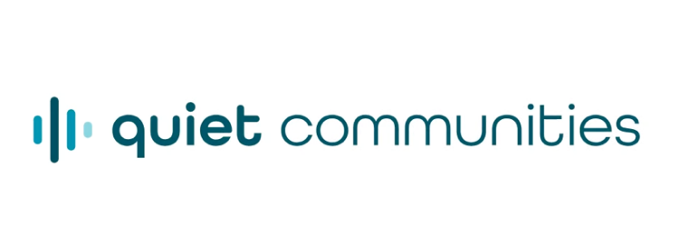
FOR IMMEDIATE RELEASE

Quiet Communities Launches Free Science-based Resource Hub to Help Communities Address Data Center Noise
Downloadable materials translate public health research and acoustical expertise into practical guidance for addressing noise throughout data center planning, construction and operation

LINCOLN, Mass., Nov. 2, 2026 — Quiet Communities, the premier nonprofit advancing scientific evidence to reduce the harmful effects of noise on public health and the environment, today launched Data Center Noise, a first-of-its-kind public resource hub on the health hazards of data center noise.
Available at quietcommunities.org/data-center-noise, the hub provides scientific research, technical expertise, and practical tools designed for residents, professionals and local officials. These downloadable resources help communities evaluate siting proposals, write or update noise ordinances, and address issues from existing facilities, including those powering artificial intelligence.

“Like energy and water consumption, noise needs to be a central consideration of every data center proposal,” said Jamie Banks, Ph.D., M.Sc., founder and president of Quiet Communities. “Chronic noise is a health hazard. For years we have worked to raise awareness of the serious impacts of noise on health and environment. This resource puts that knowledge into the hands of government officials and communities, providing actionable strategies to address noise concerns before, during and after a data center project gets established. Officials and communities should not have to wait until residents are losing sleep and suffering other health consequences to find out whether adequate protections have been put in place.”

The hub provides separate paths for residents and local officials, with shared references on health evidence and measurement. It organizes practical information around three stages: before a site is selected, while a proposed facility is under review and after operations begin.

Resources include:

- Guidance for residents on documenting data center noise complaints, understanding the limits of informal measurements – taken with a smartphone app, for example – and knowing which specific questions to ask officials and facility operators.
- A menu of 15 provisions to inform the development or revision of local noise ordinances and permit conditions, including independent acoustical review, baseline measurements before construction, verification after startup and clear enforcement responsibilities.
- Technical background for officials on evaluating low-frequency and tonal sound, reviewing equipment data and considering conditions inside nearby homes.
- An overview of data center noise and health, drawing on environmental noise research and explaining what is known specifically about data centers, with source citations and clear identification of where evidence remains limited.

“Preventing harmful noise must be a priority from the earliest stages of data center planning, and those decisions must be grounded in science,” said Chuck Elkins, former director of the Federal EPA Office of Noise Abatement and Control. "This resource hub brings together public health research and acoustical expertise to create practical resources that communities can use when evaluating proposals and writing ordinances. It gives local officials a foundation for scrutinizing noise assessments, identifying gaps in proposed protections, and establishing requirements that address how sound affects people in their homes.”

Because there is no current federal guidance, the policy provisions give local officials a starting point for developing noise protections suited to their communities. They are considerations to draw on when drafting an ordinance, rather than a complete model ordinance ready for adoption. The accompanying guidance explains why baseline measurements and an assessment of potential noise impacts before construction can provide information that is difficult to reconstruct once a facility is operating.

The hub also explains why existing noise standards applied to data centers may not fully capture the sound residents experience, including a persistent hum or other disruptive sound inside their homes. An assessment based only on an overall A-weighted decibel reading — the measure commonly used in noise limits — may not adequately capture low-frequency and tonal sound, which can penetrate walls and windows. The resources explain how additional assessment methods can provide a fuller picture of noise conditions in and around nearby homes.

Developed with input from experts across multiple disciplines, the hub gives communities a common factual basis for considering noise prevention and mitigation while recognizing that facilities and local conditions differ. Health materials distinguish broader environmental noise research from evidence specific to data centers.

Explore the hub and download resources at quietcommunities.org/data-center-noise.

About Quiet Communities
Quiet Communities, Inc. is a nonprofit organization dedicated to addressing noise pollution as a public health and environmental issue, and promoting quiet as a valuable natural resource. Founded in 2013 by health and environmental scientist Jamie Banks, Ph.D., the organization draws on scientific, medical, public policy, and legal expertise from the United States and abroad. Quiet Communities collaborates with researchers, clinicians, communities, and policymakers to build public understanding and advance evidence-informed noise policy. www.quietcommunities.org

Media Contacts:
Lisa Trapani
ltrapani@rosecomm.com
410-245-0094
###

